**STUDENT DETAILS ADDING TO DATABASE:**

**Program.cs**

using System;

using System.Collections.Generic;

using System.Linq;

namespace StudentApplicationConnectingToDb

{

class Program

{

StudentDetailsContext context;

public Program()

{

context = new StudentDetailsContext();

}

void GetAllStudentDetailsFromDatabase()

{

List<Student> students = context.students.ToList();

foreach (var item in students)

{

Console.WriteLine("Student id " + item.Id);

Console.WriteLine("Student name " + item.Name);

Console.WriteLine("Student date of joining " + item.DateofJoining);

Console.WriteLine("---------------------------------");

}

}

void AddStudents()

{

Student student = new Student();

Console.WriteLine("please enter the Student name");

student.Name = Console.ReadLine();

Console.WriteLine("please enter the Student date of joining");

student.DateofJoining = Convert.ToDateTime(Console.ReadLine());

context.students.Add(student);

context.SaveChanges();

}

void DeleteStudents()

{

Student student = new Student();

Console.WriteLine("please enter the Student id");

student.Id = Convert.ToInt32(Console.ReadLine());

context.students.Remove(student);

context.SaveChanges();

//GetAllStudentDetailsFromDatabase();

}

static void Main(string[] args)

{

Program program = new Program();

program.AddStudents();

program.DeleteStudents();

program.GetAllStudentDetailsFromDatabase();

}

}

}

**----------------------------------------------------------------------------------------------------------**

**Student.cs**

using System;

using System.Collections.Generic;

using System.Text;

namespace StudentApplicationConnectingToDb

{

public class Student

{

public int Id { get; set; }

public string Name { get; set; }

public DateTime DateofJoining { get; set; }

}

}

**----------------------------------------------------------------------------------------------------------**

**StudentDetailsContext.cs**

using Microsoft.EntityFrameworkCore;

using System;

using System.Collections.Generic;

using System.Text;

namespace StudentApplicationConnectingToDb

{

public class StudentDetailsContext:DbContext

{

protected override void OnConfiguring(DbContextOptionsBuilder optionsBuilder)

{

optionsBuilder.UseSqlServer(@"Data Source=KANINI-LTP-476\SQLSERVER2021ACH;Integrated Security=true;Initial catalog=Day13Questions1");

}

public DbSet<Student> students { get; set; }

protected override void OnModelCreating(ModelBuilder modelBuilder)

{

//first three values are added during migration

modelBuilder.Entity<Student>().HasData(new Student()

{

Id = 101,

Name = "jack",

DateofJoining = Convert.ToDateTime("13/08/21")

});

modelBuilder.Entity<Student>().HasData(new Student()

{

Id = 102,

Name = "jill",

DateofJoining = Convert.ToDateTime("12/08/21")

});

modelBuilder.Entity<Student>().HasData(new Student()

{

Id = 103,

Name = "james",

DateofJoining = Convert.ToDateTime("20/08/21")

});

}

}

}

**----------------------------------------------------------------------------------------------------------**

**InitialMigration.cs**

using System;

using Microsoft.EntityFrameworkCore.Migrations;

namespace StudentApplicationConnectingToDb.Migrations

{

public partial class initialMigration : Migration

{

protected override void Up(MigrationBuilder migrationBuilder)

{

migrationBuilder.CreateTable(

name: "students",

columns: table => new

{

Id = table.Column<int>(type: "int", nullable: false)

.Annotation("SqlServer:Identity", "1, 1"),

Name = table.Column<string>(type: "nvarchar(max)", nullable: true),

DateofJoining = table.Column<DateTime>(type: "datetime2", nullable: false)

},

constraints: table =>

{

table.PrimaryKey("PK_students", x => x.Id);

});

migrationBuilder.InsertData(

table: "students",

columns: new[] { "Id", "DateofJoining", "Name" },

values: new object[] { 101, new DateTime(2021, 8, 13, 0, 0, 0, 0, DateTimeKind.Unspecified), "jack" });

migrationBuilder.InsertData(

table: "students",

columns: new[] { "Id", "DateofJoining", "Name" },

values: new object[] { 102, new DateTime(2021, 8, 12, 0, 0, 0, 0, DateTimeKind.Unspecified), "jill" });

migrationBuilder.InsertData(

table: "students",

columns: new[] { "Id", "DateofJoining", "Name" },

values: new object[] { 103, new DateTime(2021, 8, 20, 0, 0, 0, 0, DateTimeKind.Unspecified), "james" });

}

protected override void Down(MigrationBuilder migrationBuilder)

{

migrationBuilder.DropTable(

name: "students");

}

}

}

OUTPUT:

**Displaying the inserted values:**

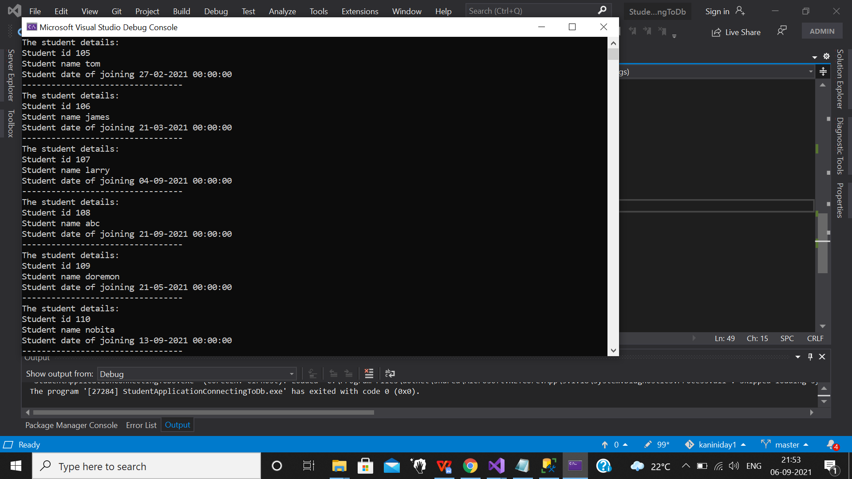

**INSERTING VALUES IN THE TABLE AND DISPLAYING THE VALUES:**

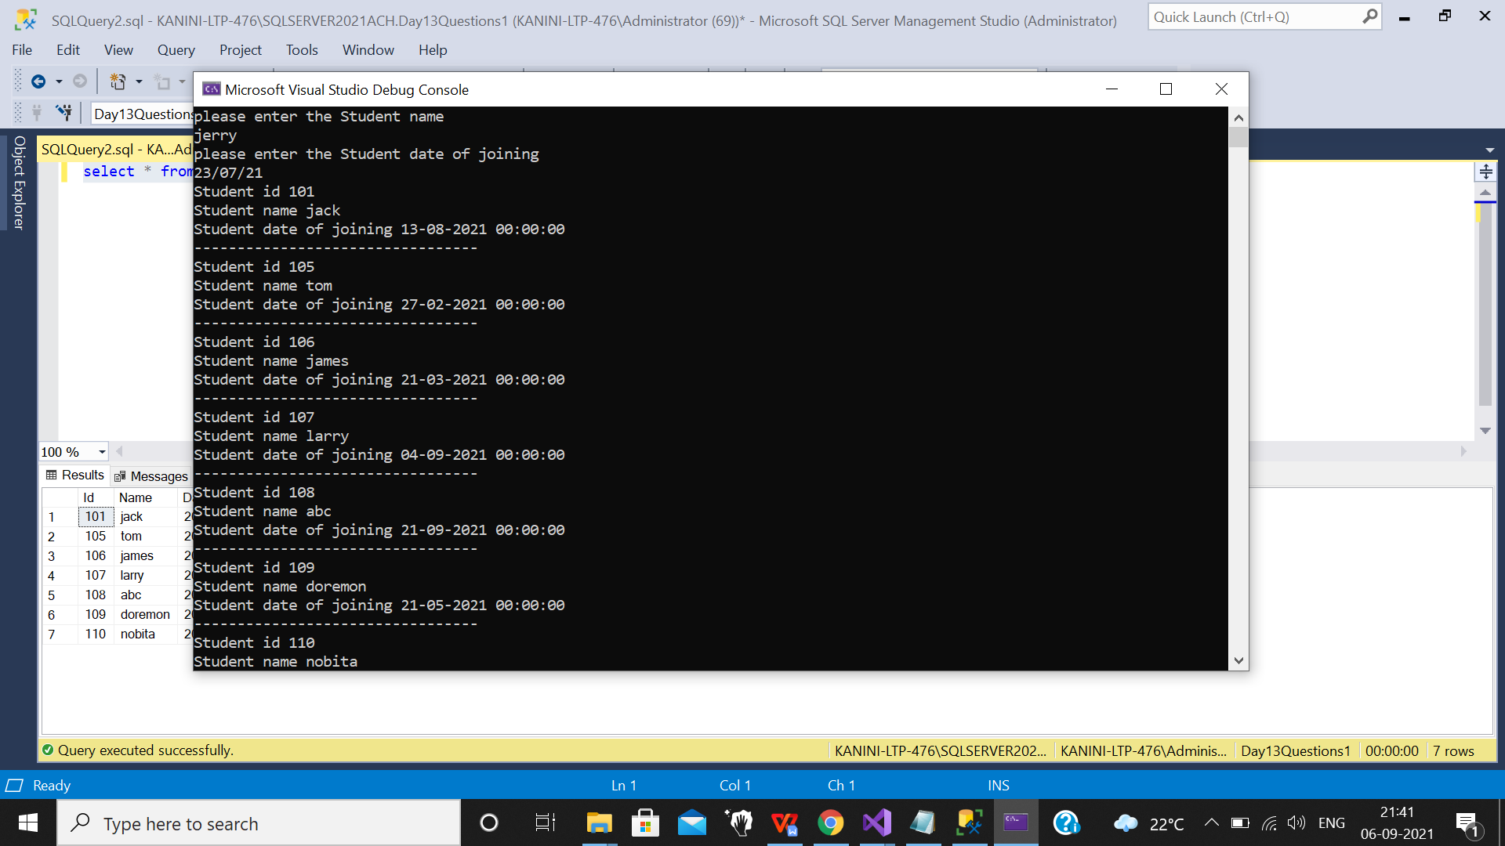

**Displaying values after deleting a tuple from the table and displaying the remaining:**

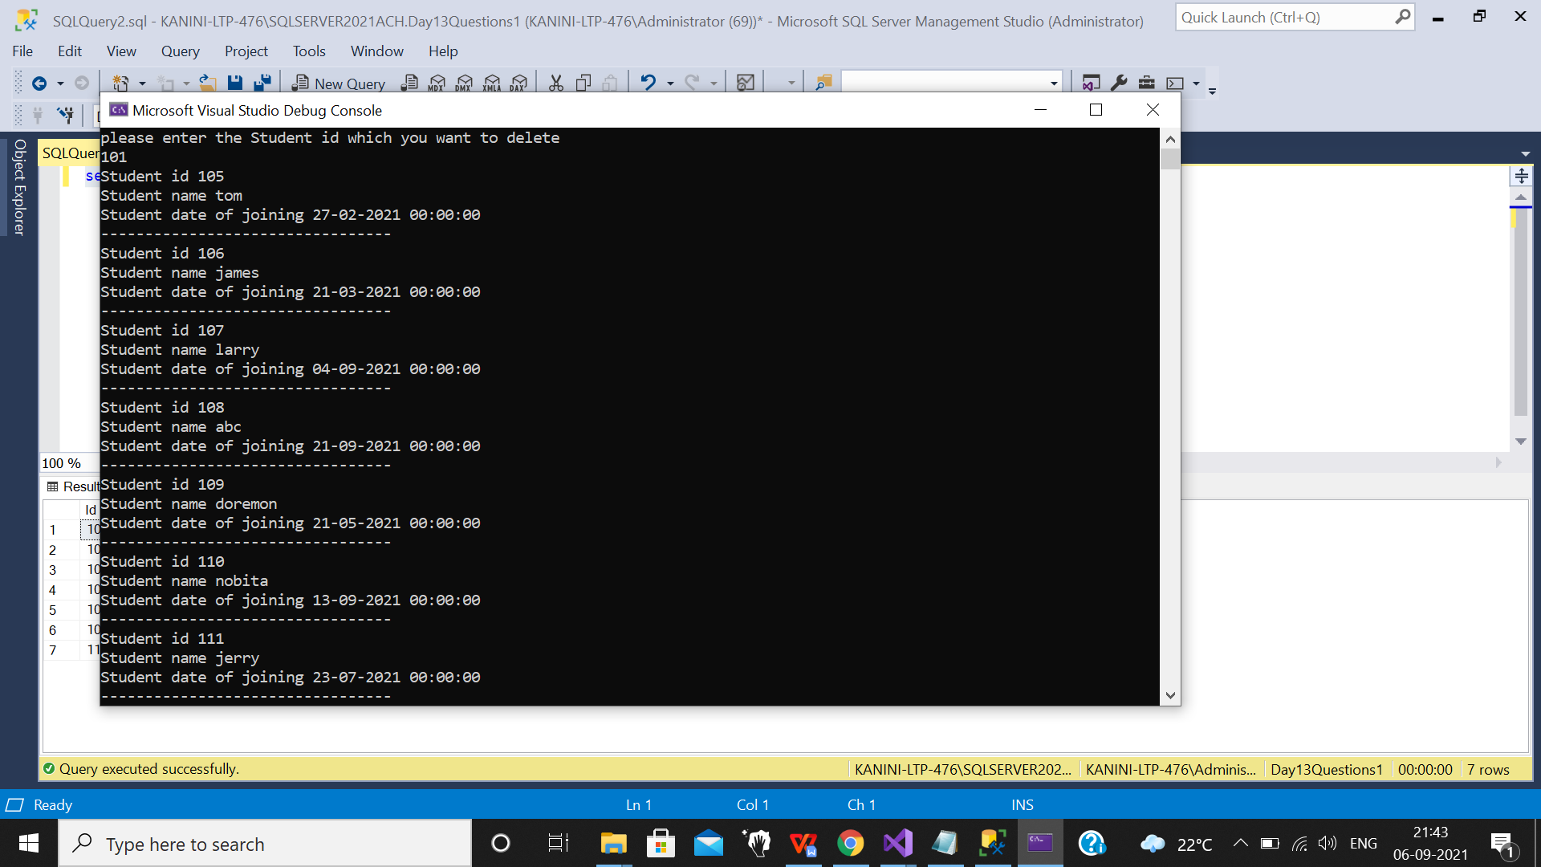

**DATABASE:**

Database where values is added to the table student and displayed after modifications such as deletion of tuple or adding a tuple

